Moreno, Melissa

SUR5386

Tutorial 2: ENVI

2.ii – 2.iv

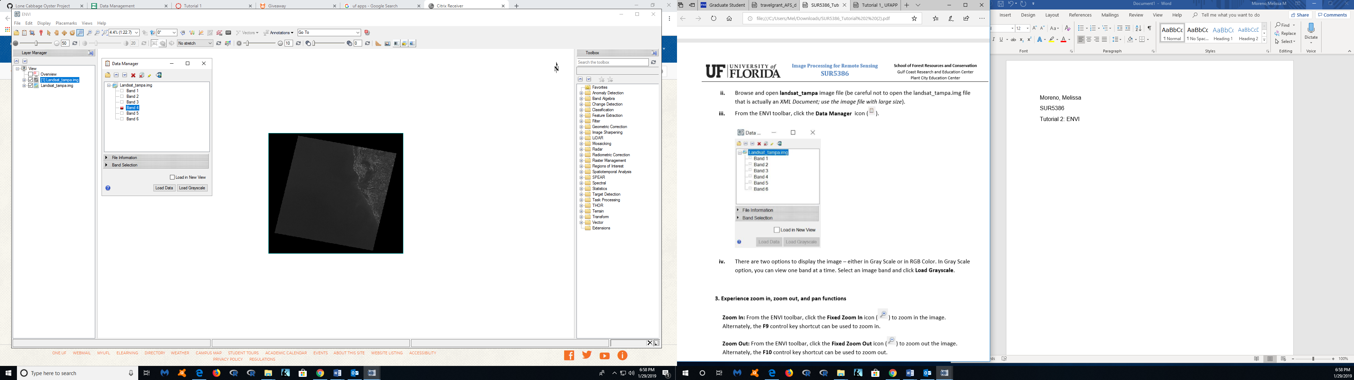

Selecting Band 6 in grayscale.

3. Zoom in

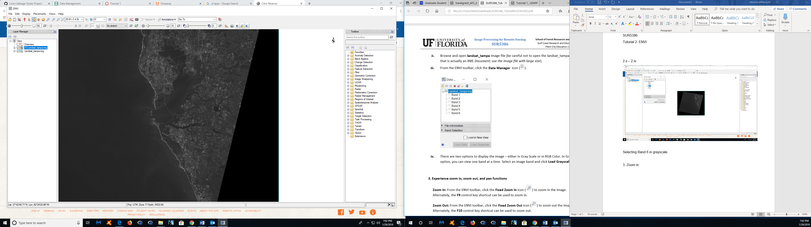

3. Zoom out

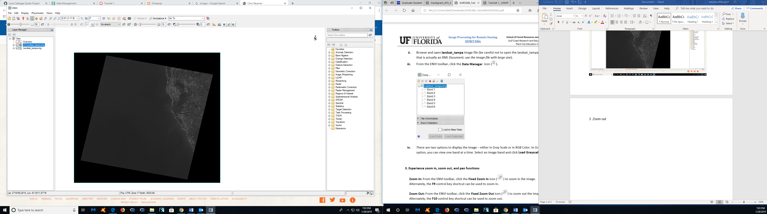

3. Full extents

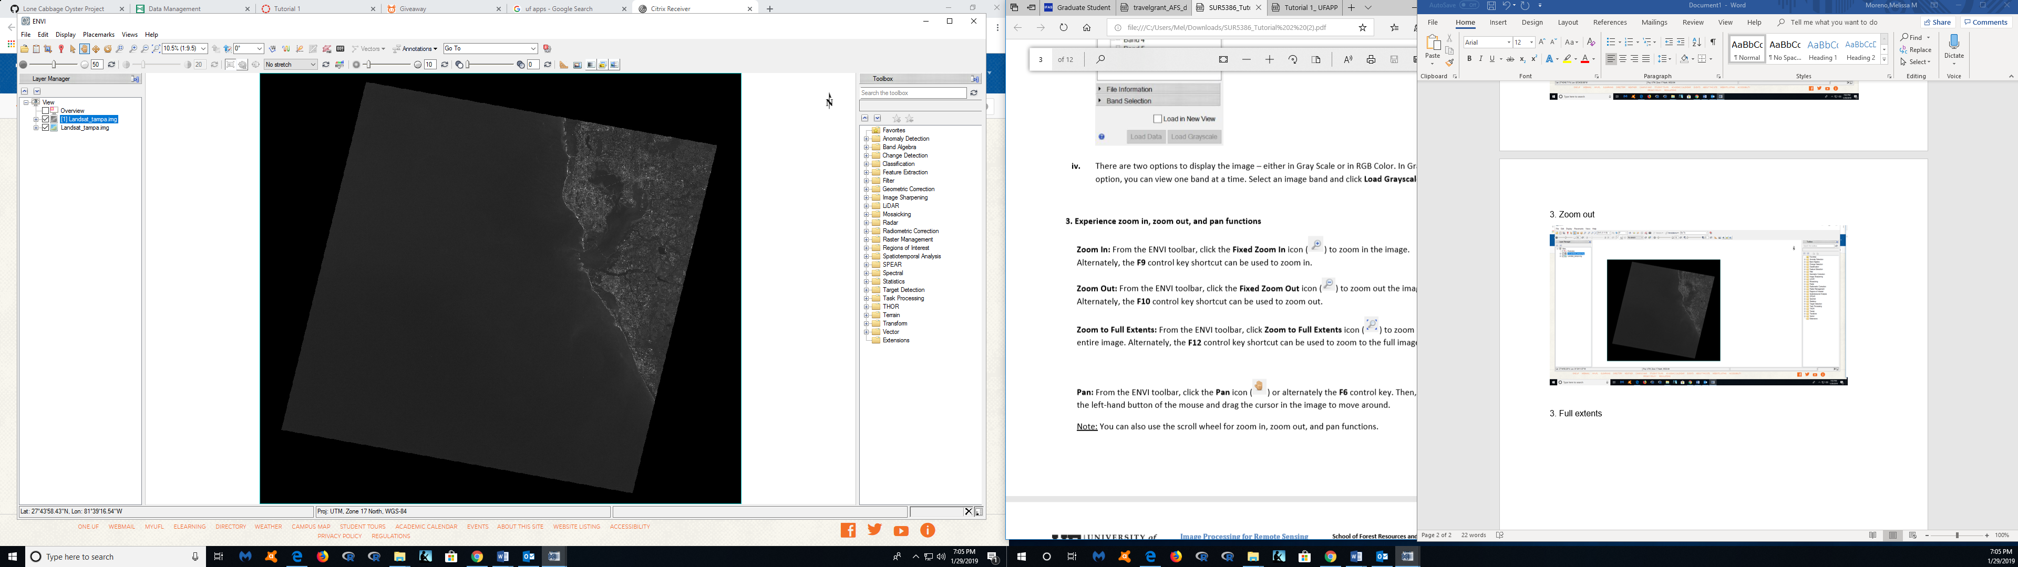

3. Pan

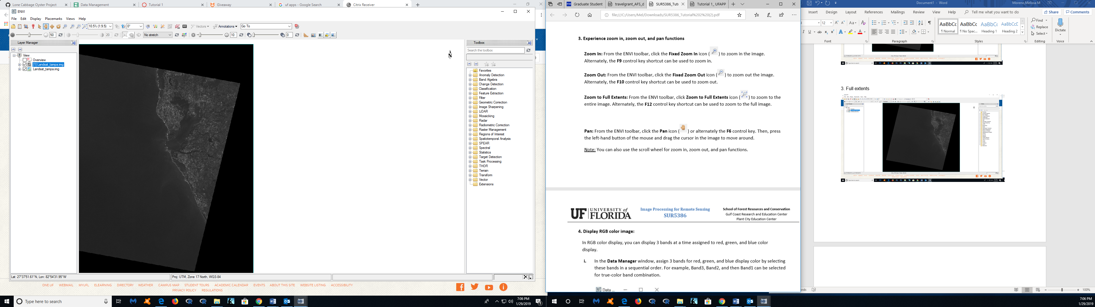

4.i

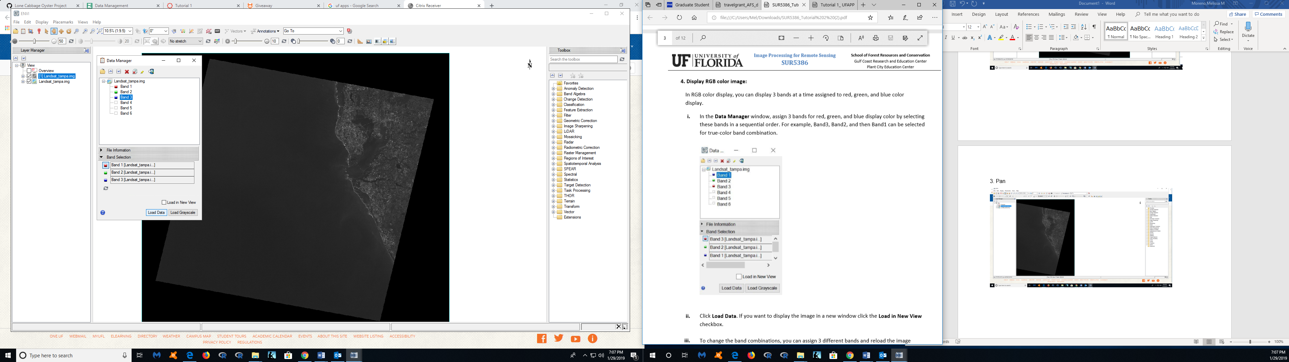

4.iii

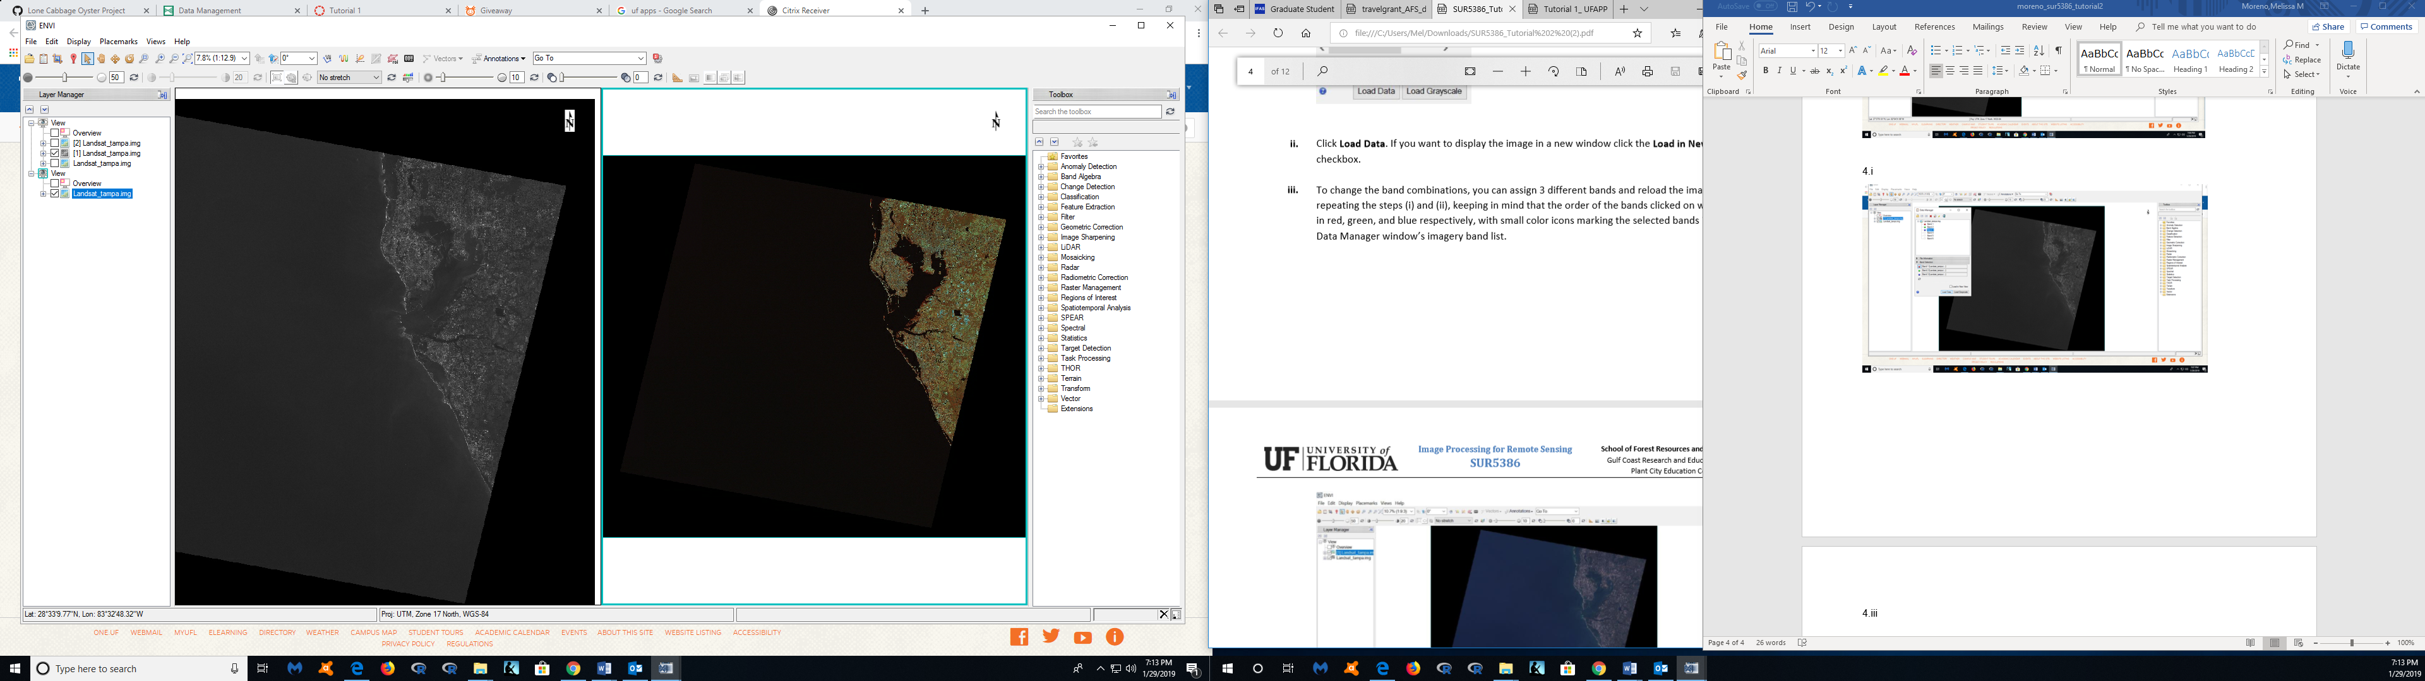

5. ii

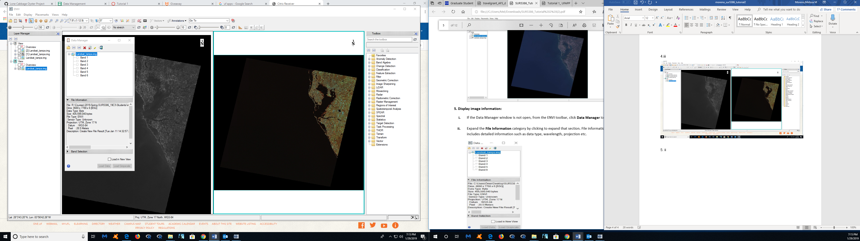

6.i

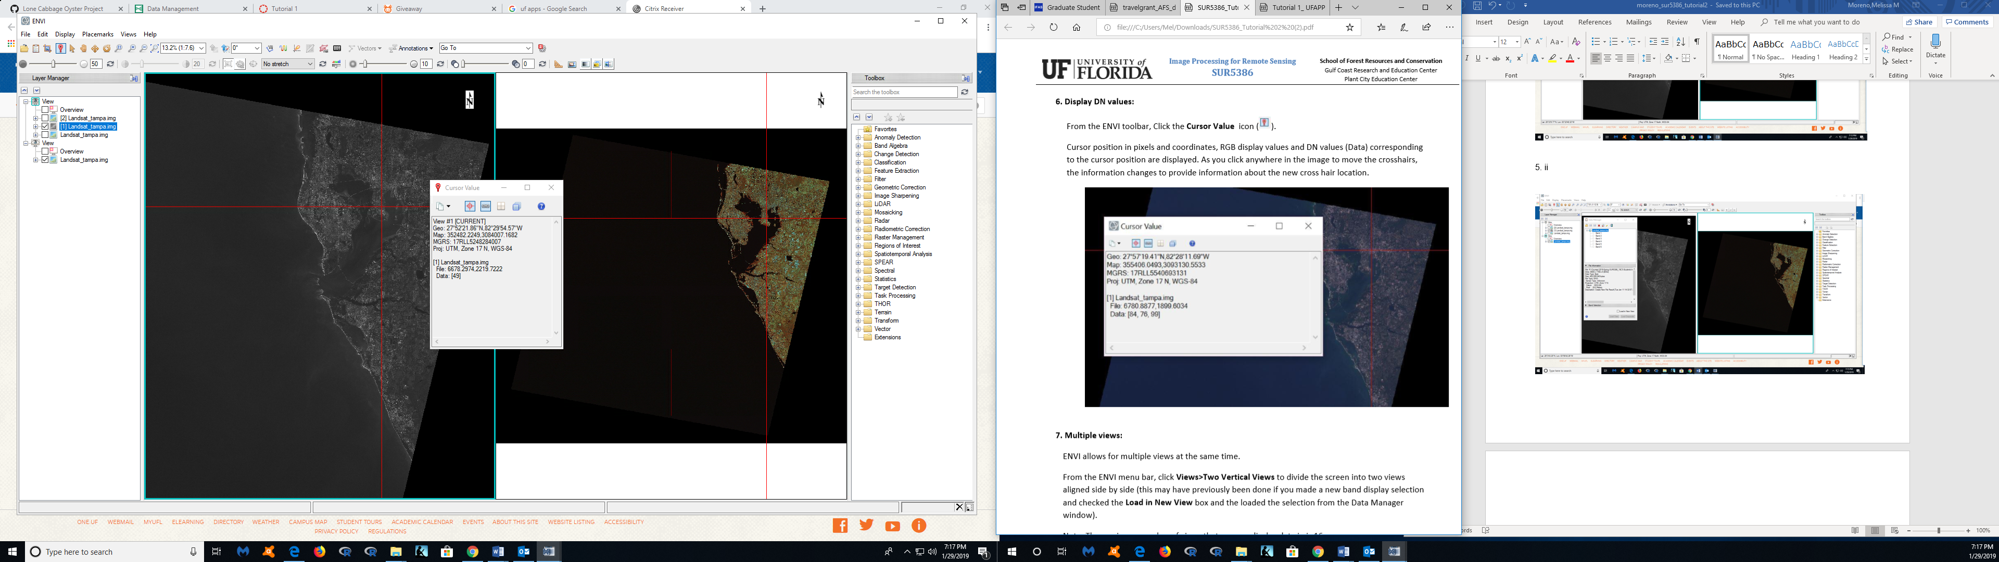

7. i

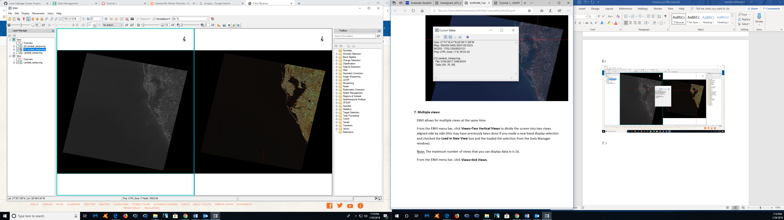

7.ii

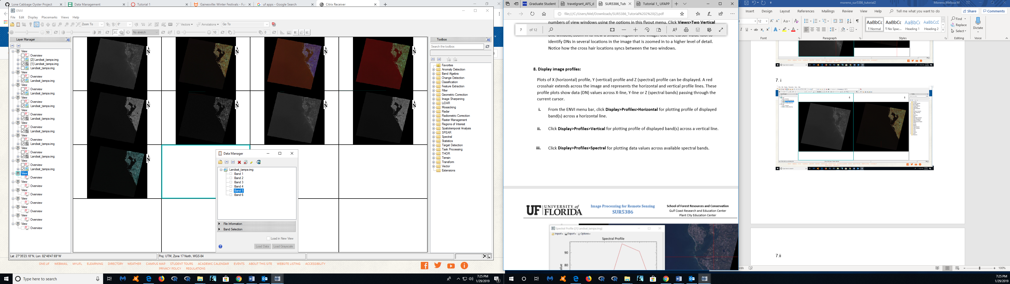

8.iii

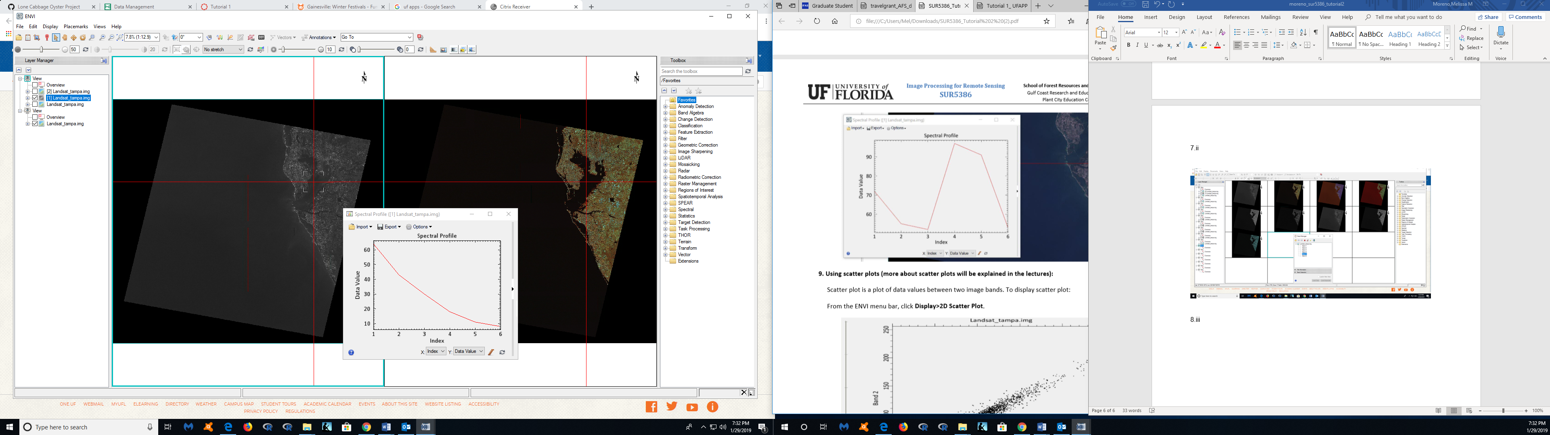

9.i

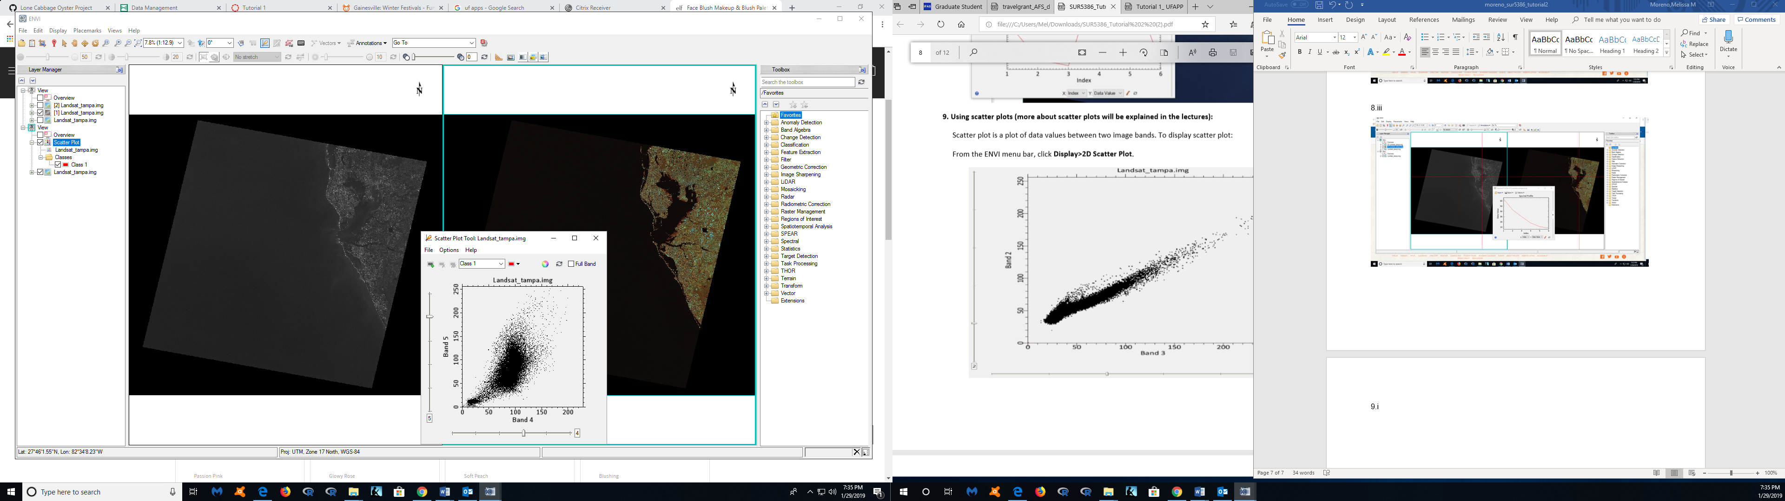

10. iv

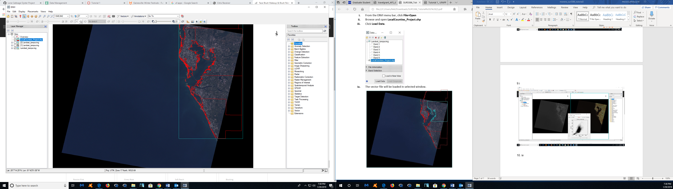

10.vi

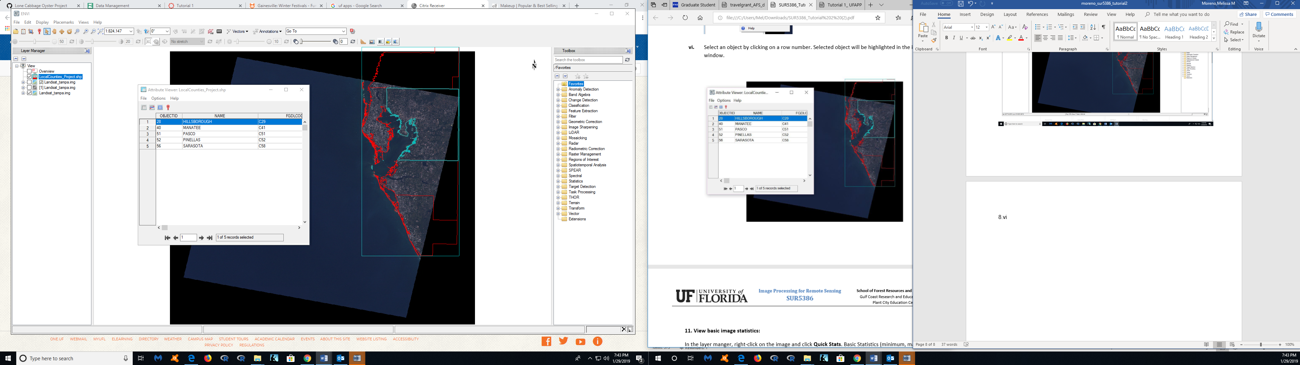

11.i

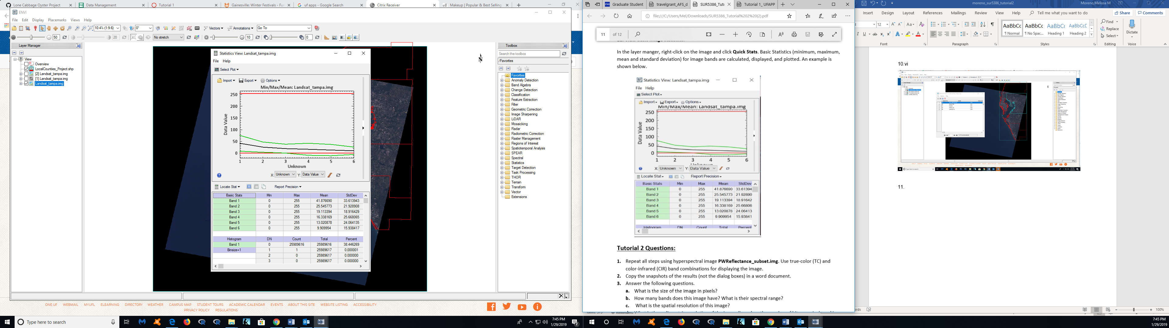

**Tutorial 2 Questions:**

1.i – 2.iii

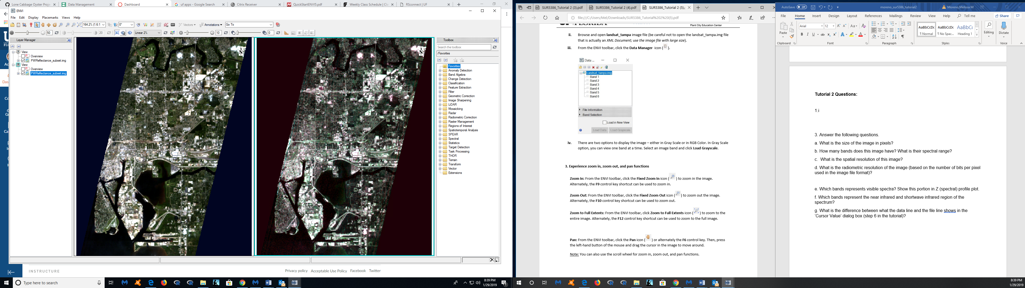

3. Zoom in

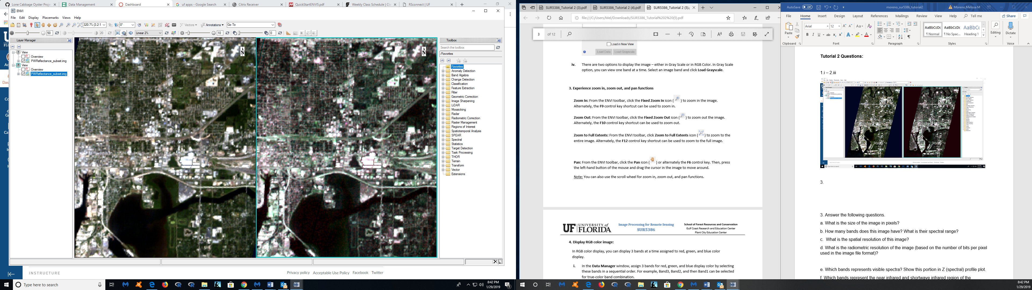

3. Zoom out

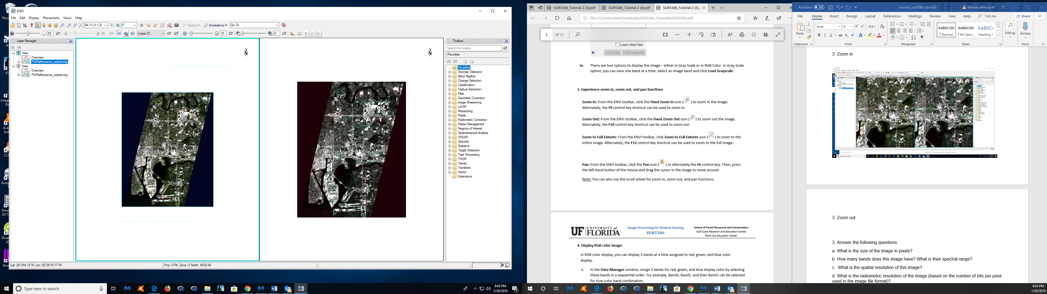

3. Zoom to full extents

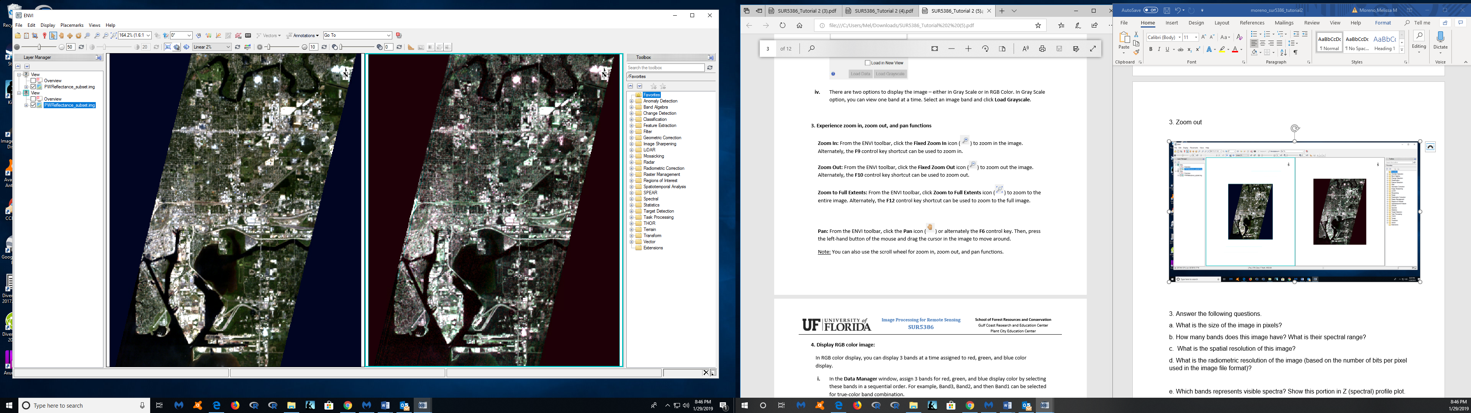

5.i- 5.ii

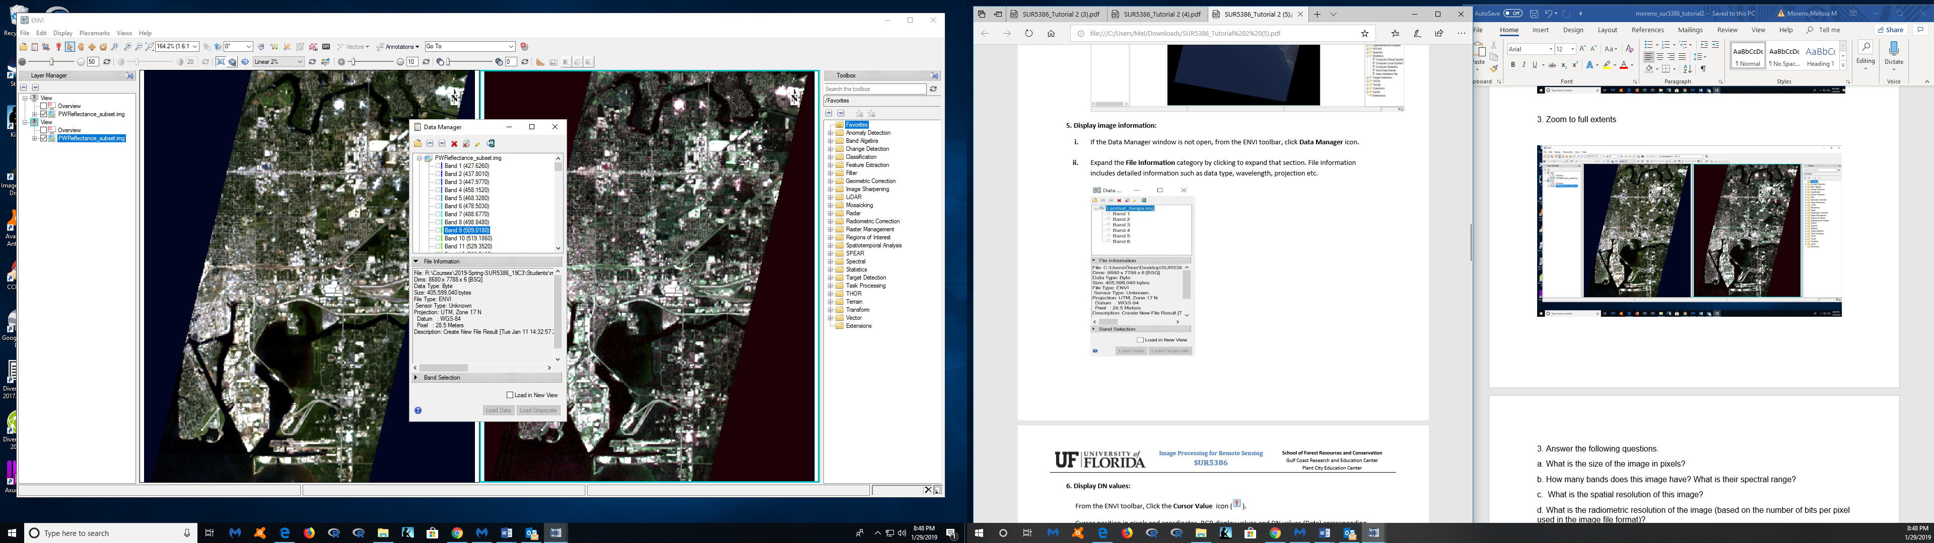

6.

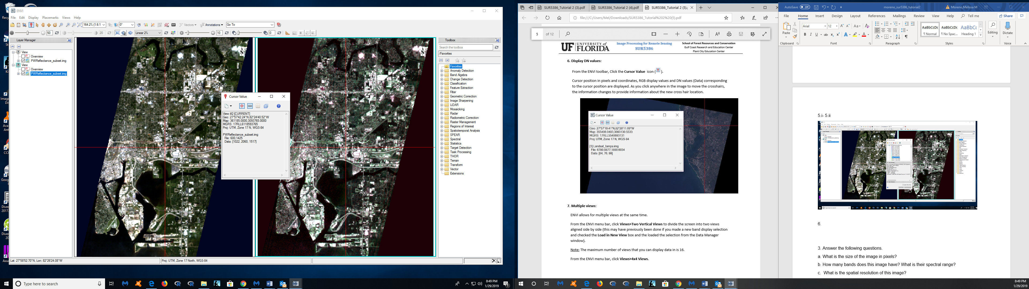

7.

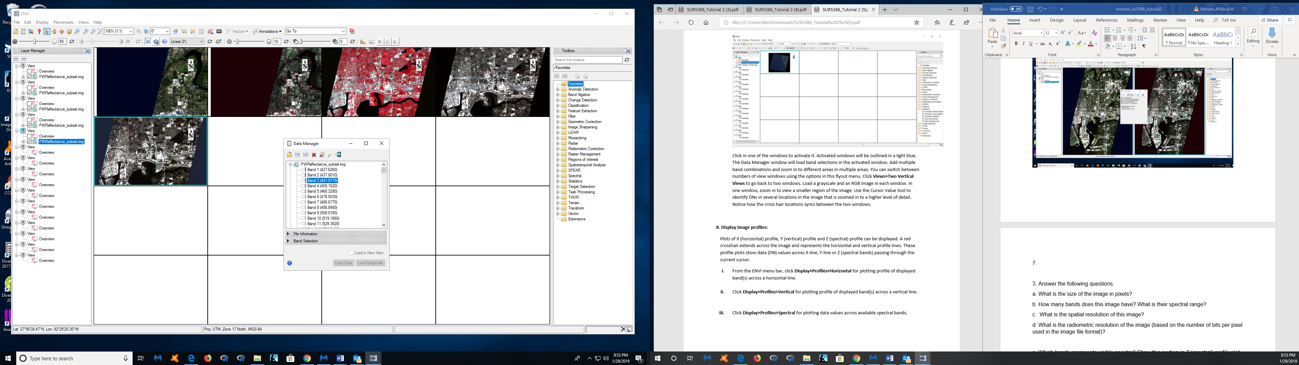

8.i

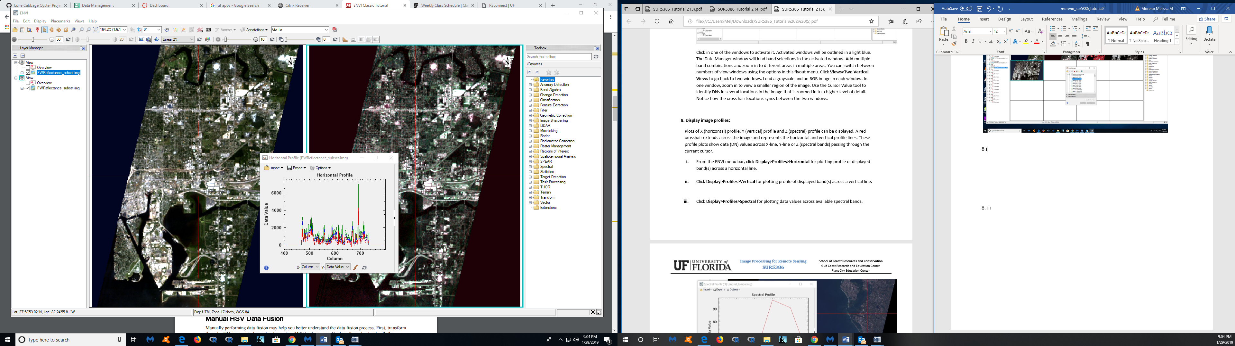

8.ii

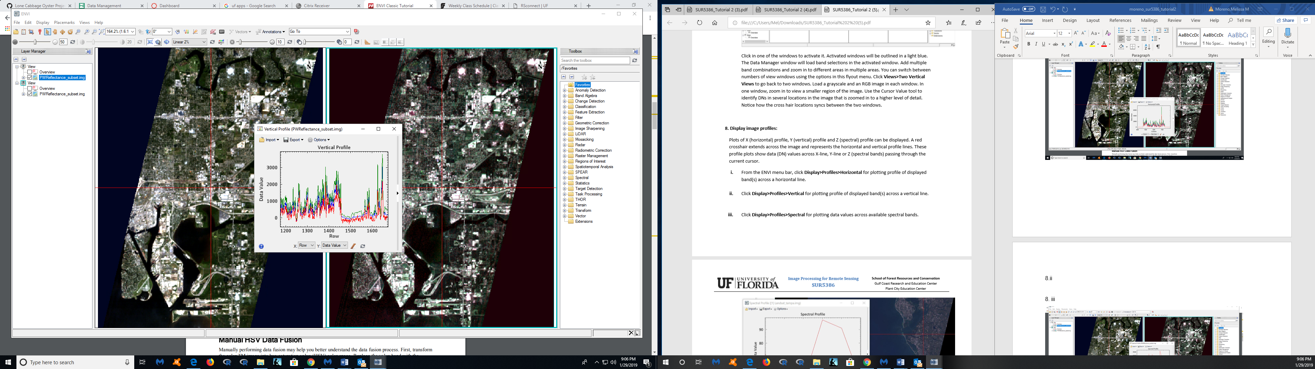

8. iii

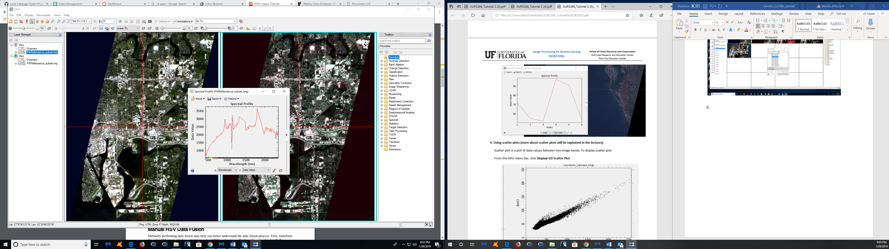

9.

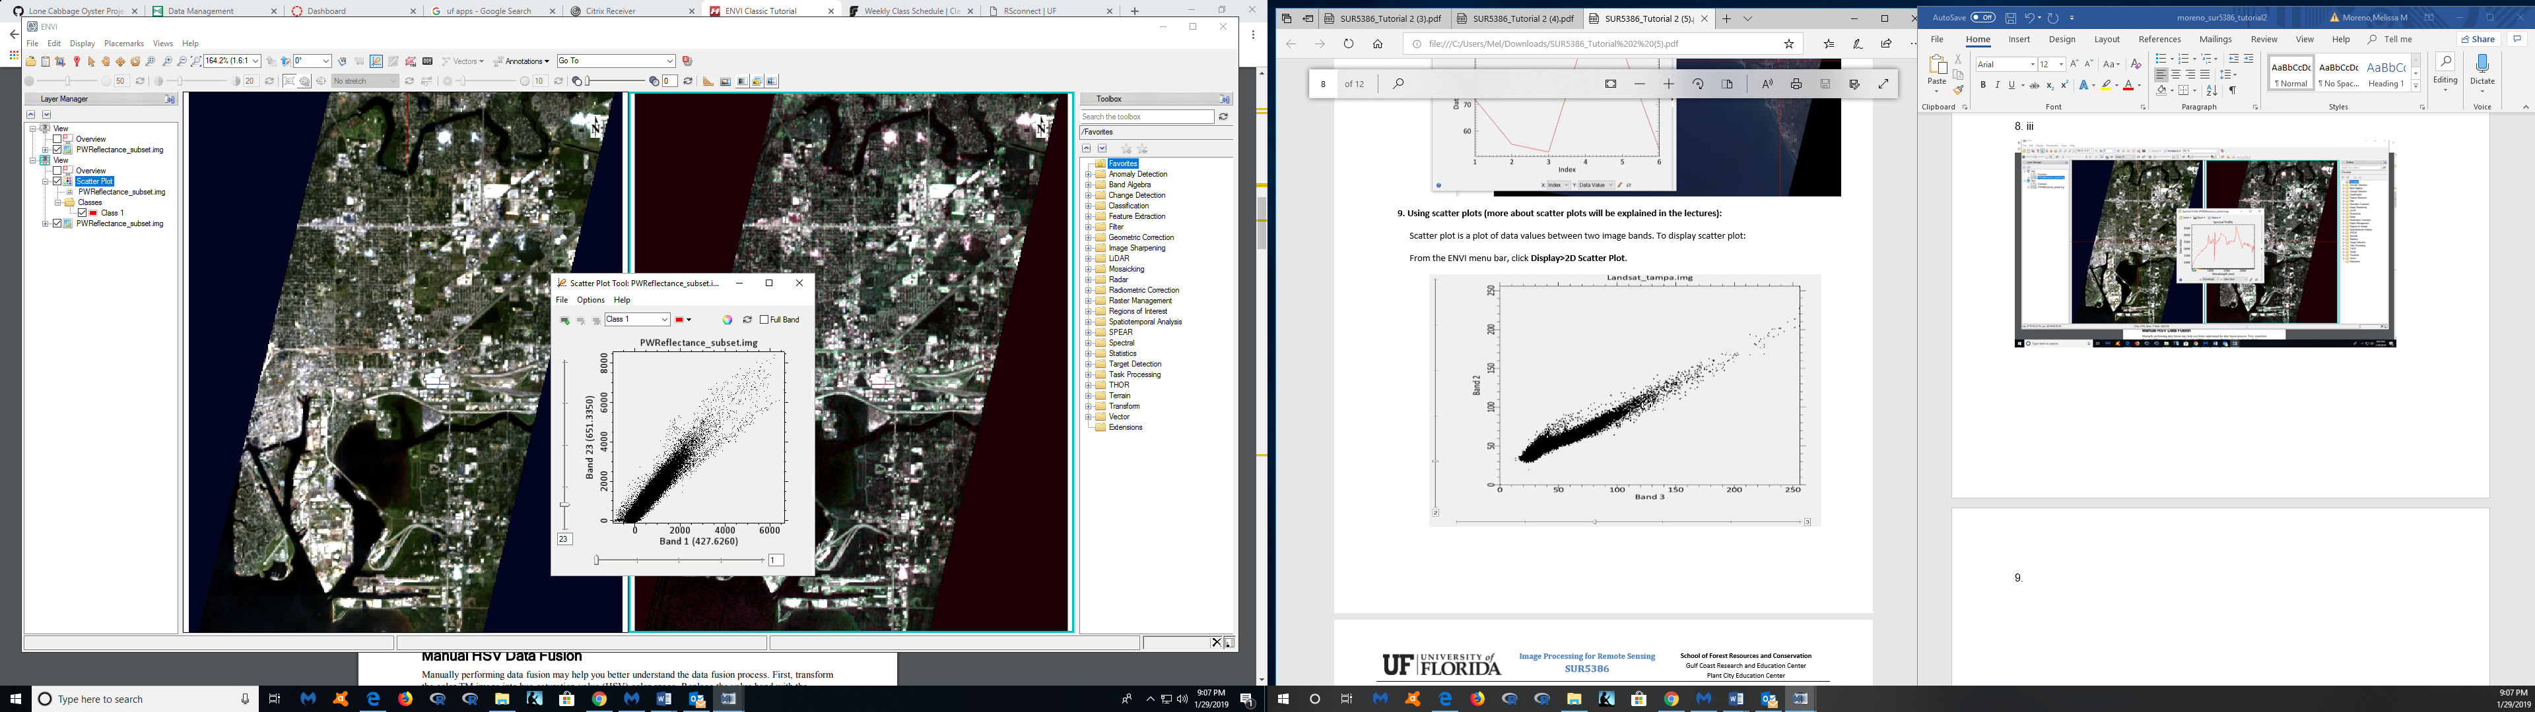

10. No county information for this

11.

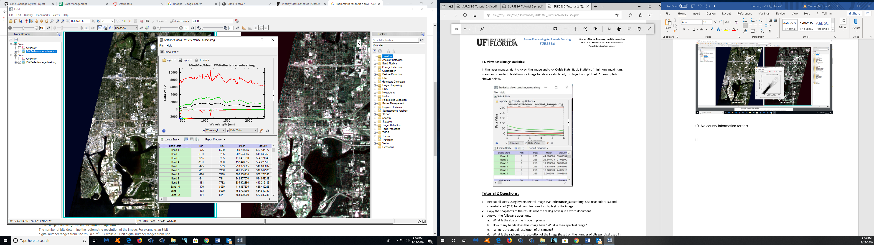

a. What is the size of the image in pixels?

Dimensions= 8680 x 778 x 6

Number of pixels- 8600 x 778 = 6690800

b. How many bands does this image have? 158 bands

What is their spectral range? 427.6260 - 2357.9099 nm

c. What is the spatial resolution of this image?

1 pixel = 30 meters

d. What is the radiometric resolution of the image (based on the number of bits per pixel used in the image file format)?

Size: 63,200,000 bytes * 8 bits = 505,6000,000 / 158 bands = 3,200,000 bytes

1 byte = 8-bits

e. Which bands represents visible spectra? Show this portion in Z (spectral) profile plot.

The bands that represent the visible spectra range from 380- 770 nm.

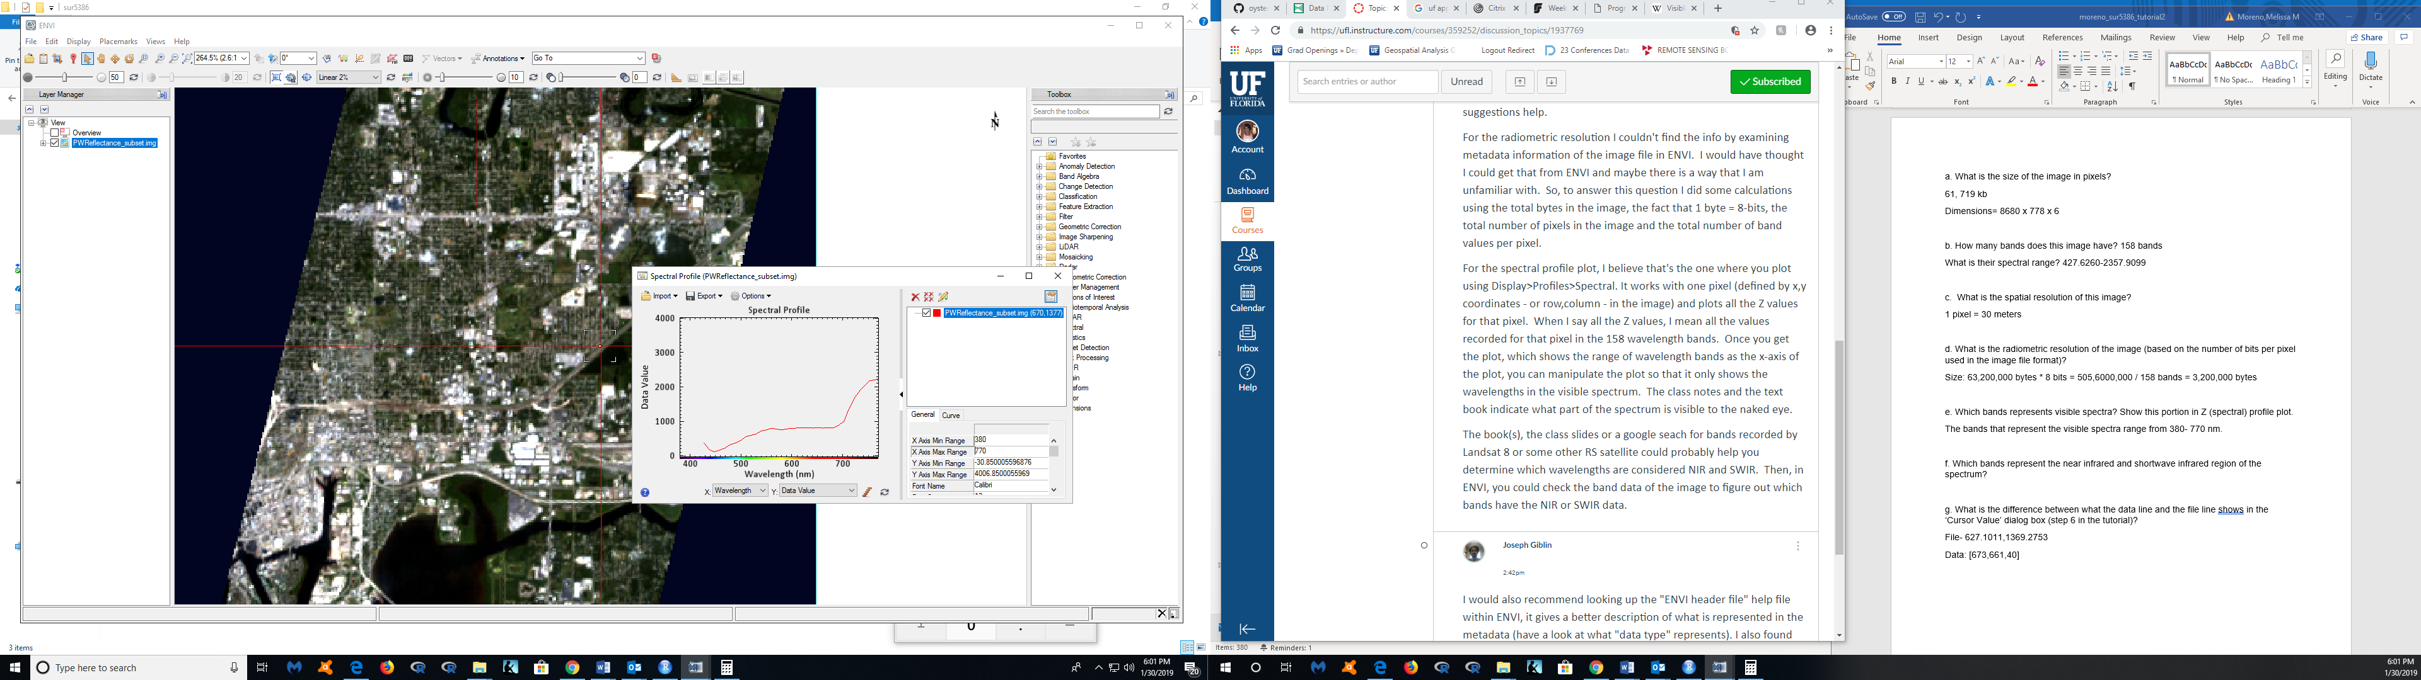

f. Which bands represent the near infrared and shortwave infrared region of the spectrum?

Near infrared- 760-900 nm

Bands 32-47

Shortwave infrared- 1,100 to 3,000 nm

Bands 68- 158

g. What is the difference between what the data line and the file line shows in the ‘Cursor Value’ dialog box (step 6 in the tutorial)?

File- 627.1011,1369.2753

Data: [673,661,40]

